Appendix 1 Codes of Conduct

BACKGROUND
The following Ulster Branch Code of Conduct (#respectURgame) is based on the current IRFU Codes of Conduct which have been developed specifically as part of the IRFU Spirit of Rugby Programme https://www.irishrugby.ie/playing-the-game/spirit-of-rugby/ and relate to the IRFU Safeguarding Policy https://www.irishrugby.ie/playing-the-game/spirit-of-rugby/safeguarding/safeguarding-policy/

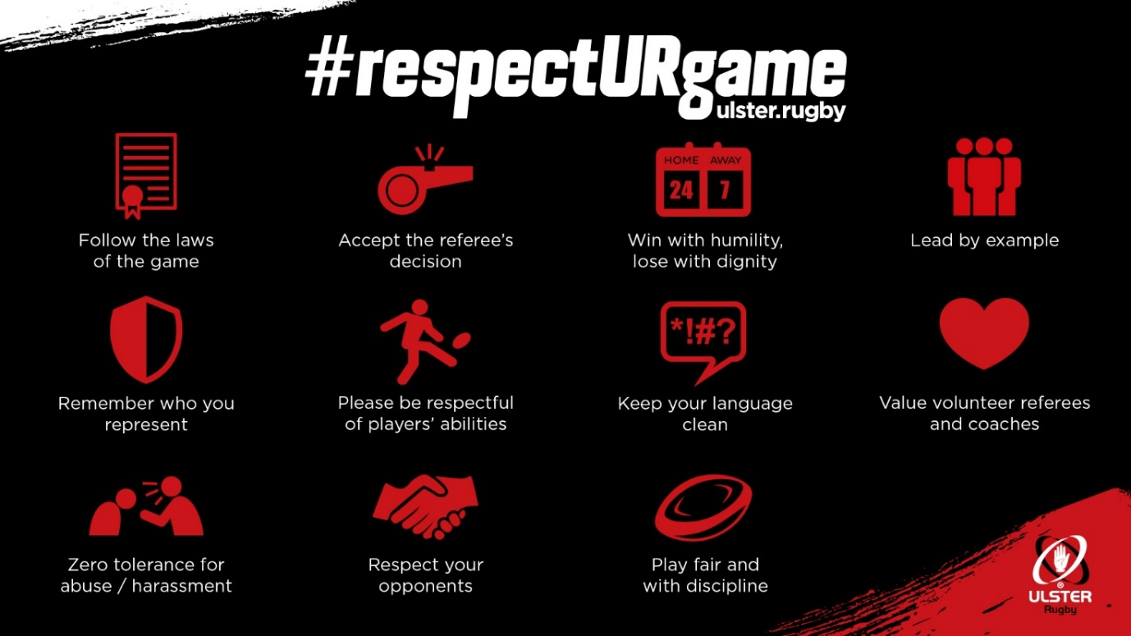
https://ulster.rugby/rugby-in-ulster/rugby-development/resources/respecturgame

Codes of Conduct for Mini and Youth Players, Parents, Spectators and Referees
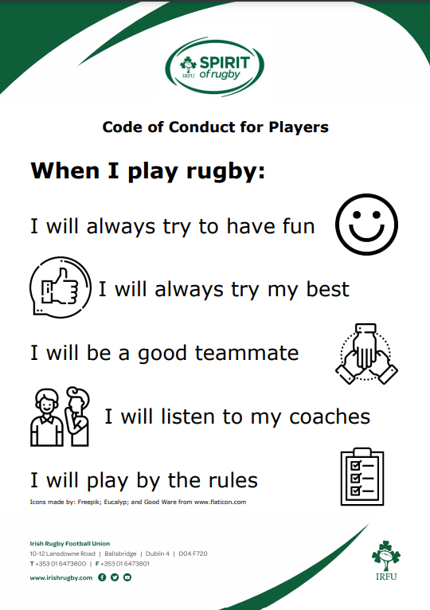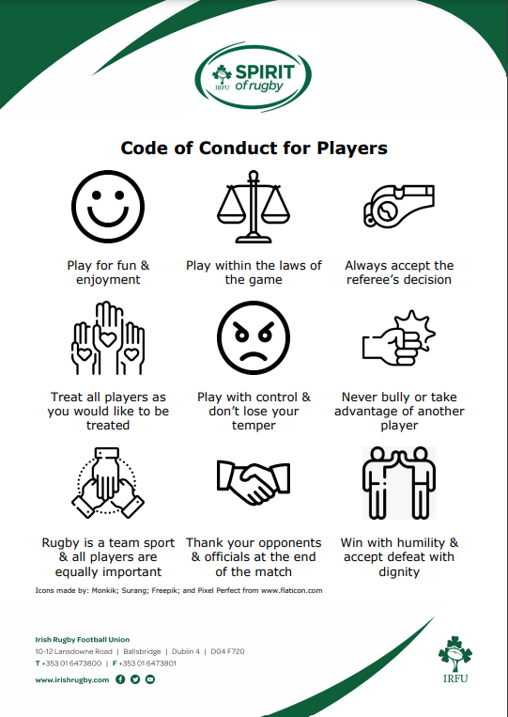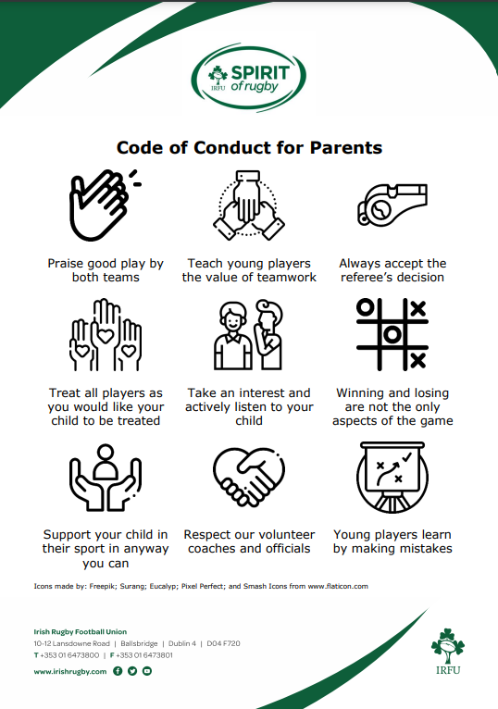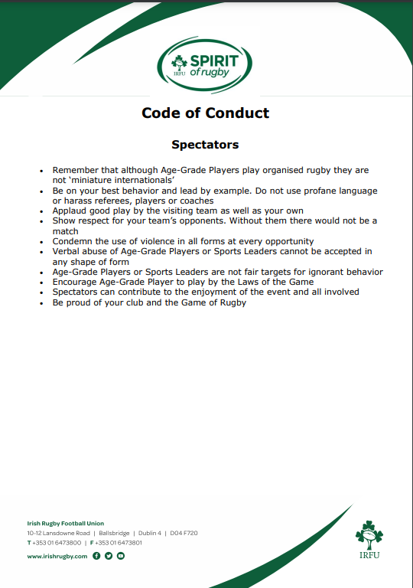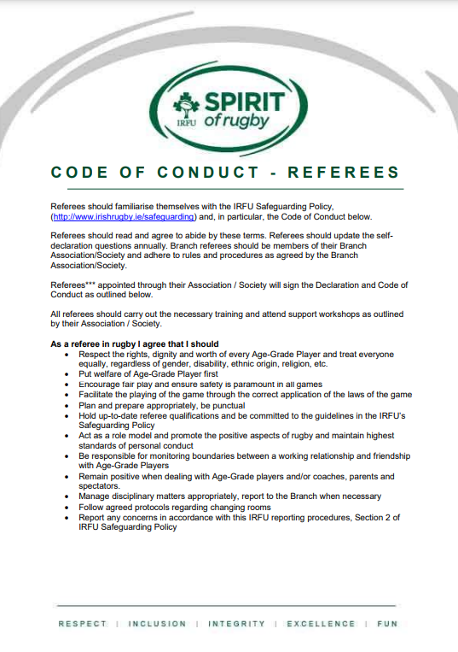
https://www.irishrugby.ie/playing-the-game/spirit-of-rugby/safeguarding/best-practice/

Code of Conduct for Coaches
All coaches and volunteers working on a regular basis with children and young people should be aware of the IRFU Safeguarding Policy https://www.irishrugby.ie/playing-the-game/spirit-of-rugby/safeguarding/safeguarding-policy/ and after reading it, sign the Declaration of Intent on RugbyConnect https://rugbyconnect.irfu.ie/

There are lots of useful resources for clubs https://www.irishrugby.ie/playing-the-game/spirit-of-rugby/safeguarding/best-practice/ and for parents https://www.irishrugby.ie/playing-the-game/spirit-of-rugby/safeguarding/parents-guardians/ including how to effectively communicate with young players.

SOCIAL MEDIA
Remember that social media postings and emails can be circulated well beyond your intended audience. Show the same standards of behaviour and respect when commenting on rugby matches on social media as you would at the match itself.
Comment positively on matches, giving credit to opposition teams as well as your own.
Do not raise any concerns or grievances you may have via social media. If you have a genuine concern, please raise this through your club or school using the proper procedures.
Images
Guidance around the use of images, especially of young players is available on the IRFU website. This should assist clubs to develop their own policy, https://www.irishrugby.ie/playing-the-game/spirit-of-rugby/safeguarding/best-practice/

